
Regional Assignment of Counties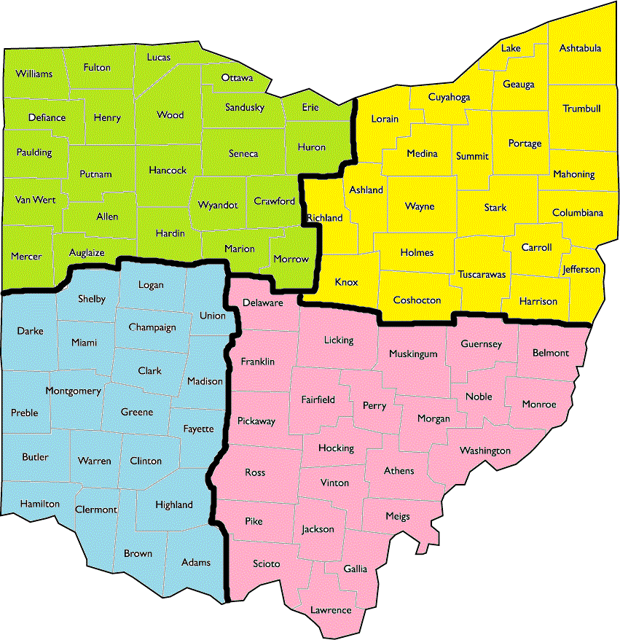
Northwest
Northeast
Southwest
Southeast

